Модуль 6

Advances in Space Research
Topic: Advances in Space Research
Grammar: Modal Verbs
Essential Vocabulary: gravity, weightlessness, raw materials, advent, improve, sustain, dedicate, process, although, vital, impurity, eliminate, allow, precisely

- Look at the pictures and match them to the words in the box

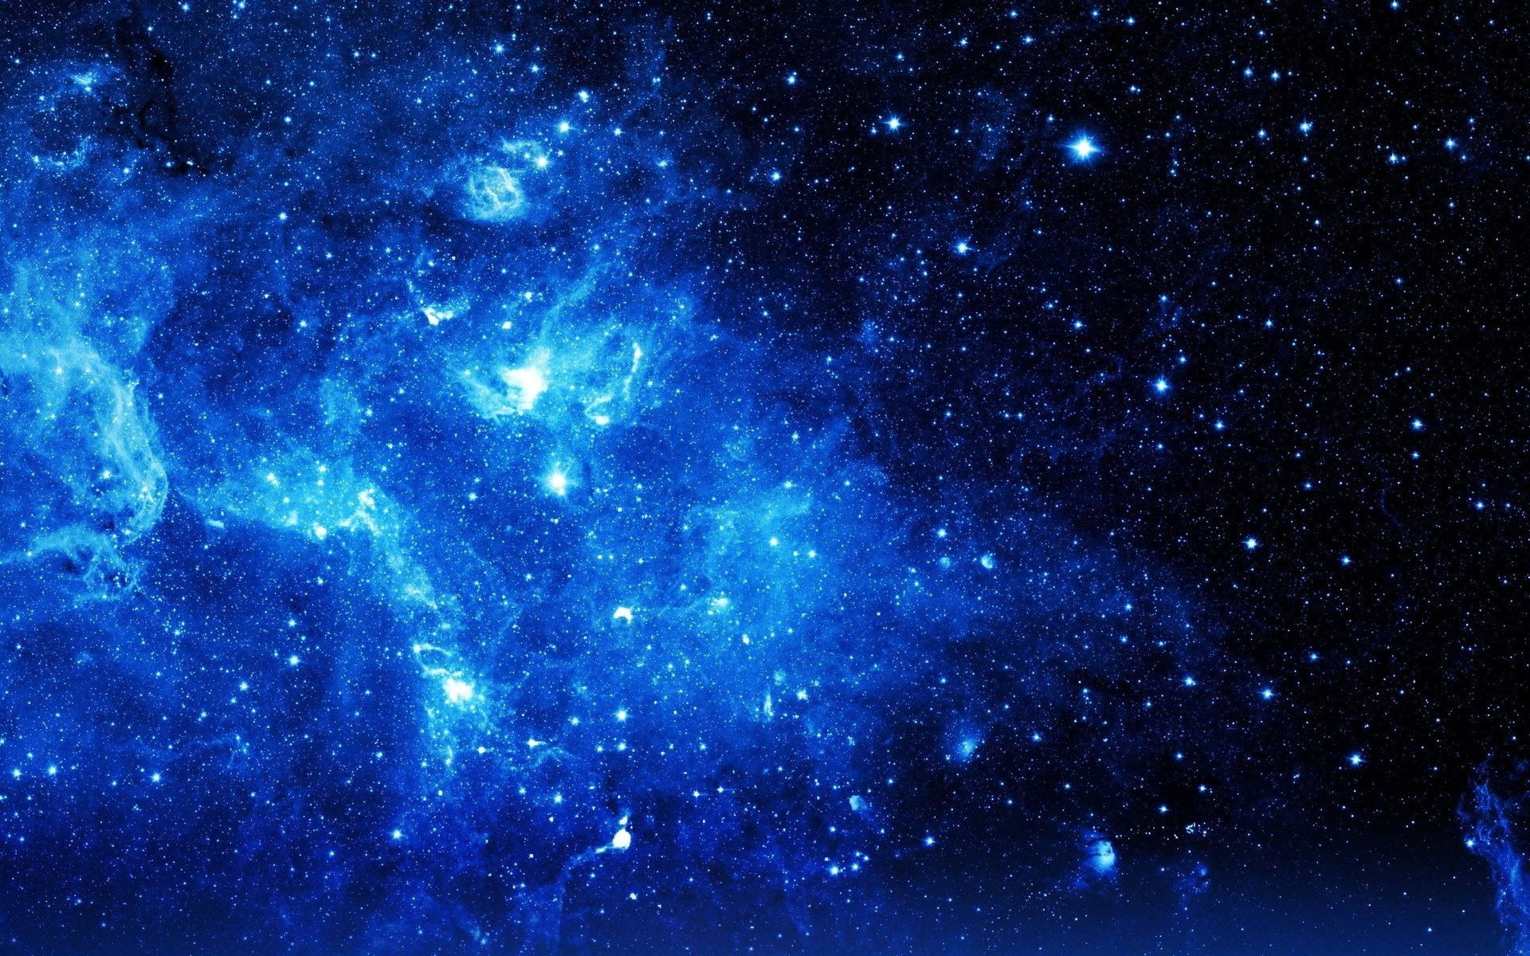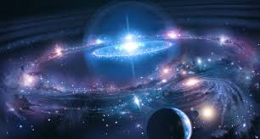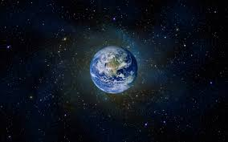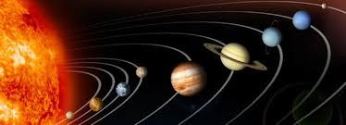

1________________ 2___________________ 3________________ 4____________

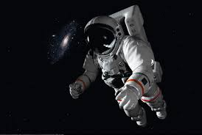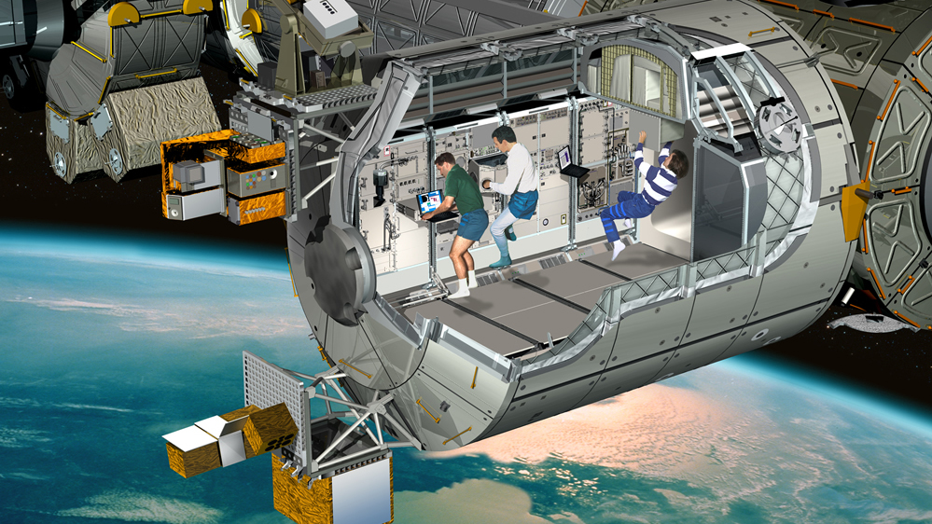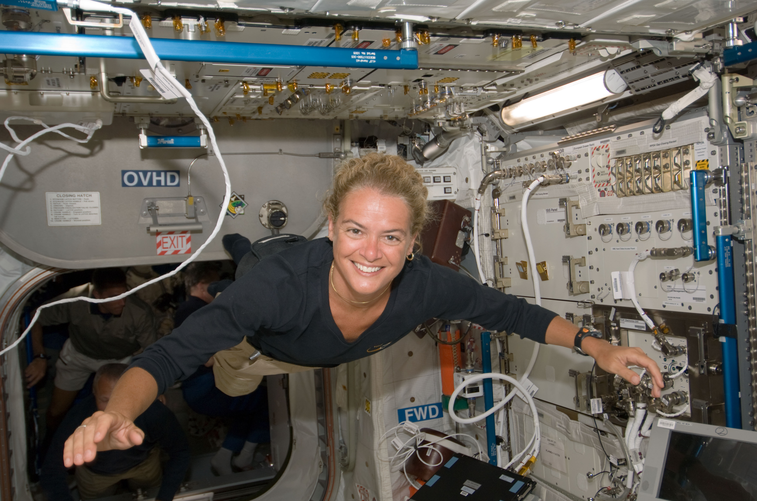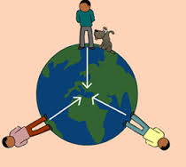

5_________________ 6__________________ 7_________________ 8______________

Earth, astronaut, Universe, gravity, planets, space, weightlessness, ISS

- Answer the questions and discuss your answers in pairs:
- Have you ever dreamed to be an astronaut or a space researcher?
- Is space research important for humanity? Why?
- Can space technologies be beneficial for our life on Earth?
- What is the difference between Earth and space conditions?
3.
Could you be an astronaut?
Listen to a small talk. Before you start listening look at the following words and expressions to better understand the talk:
to get on each other's nerves/annoy - раздражать
to put up with - мириться, терпеть
zero gravity - отсутствие силы тяжести
somersaults - кувырки
to float - всплывать, плавать
to exert no force - не оказывать влияния
wasting of the bones and muscles – атрофия костей и мышц
to prevent - предотвращать
weightlessness - невесомость
buoyancy |ˈbɔɪənsi| - плавучесть; подъёмная сила; жизнерадостность; бодрость
padded - оббитый, мягий
altitude |ˈaltɪtjuːd| - высота
nosedive - пикирование
to conduct - проводить
to get stranded - попасть в бедственное положение
forage - добывать продовольствие
keen to know - стремиться узнать
to apply - подавать заявление
to give up - отказаться
to run out of time- испытывать дефицит времени

4. Are the statements true (T) or false (F)? Correct the wrong statements.
- A few dozens of people have been into space so far.
- Astronauts have to put up with extremely high gravity in space.
- Wasting of bones and muscles is the result of zero gravity.
- Astronauts can use a virtual reality headset and special gloves to prepare them for
weightlessness and spacewalking.
- Astronauts practise their spacewalk in pools with sand.
- The European Space Agency sends astronauts to Russia for the survival training.
- When the space capsule lands somewhere unexpected, astronauts have to find food for themselves.
- According to Nasa's website, 18 000 people applied to join their 2017 astronaut class.

5. Fill in gaps with words from a box
Water, before, zero gravity, practise, exerting, weightlessness, out, spacewalk, prevent, float, conduct, exercise, swimming pool, planes, feels like, similar, sudden

Zero gravity – a condition where gravity is __________no force – can lead to wasting of the bones and muscles. Astronauts take two and a half hours of _________per day to help ________this. But what do astronauts have to do _______they go into space, to prepare them for ____________and spacewalking? They can _________using a virtual reality headset and special gloves. It's like playing a computer game that looks and _________doing a spacewalk. And they also train in a_________! The way astronauts practise _______is in water. _______ gives them the neutral buoyancy that they need. Buoyancy is the ability to__________. Floating in space is ________ to floating in water. Astronauts experience the feeling of weightlessness in ________ too. A large plane with padded walls flies to high altitude and then goes into a _______ fall which creates short periods of weightlessness. But it's not all fun and games. The main reasons for being ______on the International Space Station is to _________research. Major Tim Peake is doing scientific experiments, such as how to grow plants in space and what effect radiation and ____ _______have on this process.
Speaking
6. Summarize the information above. Use these questions to help you prepare your summary.
1. How many people have been in space so far?
2. What are the biggest challenges astronauts have to put up with?
3. What is zero gravity or weightlessness? What negative effects does it have on people?
How can this be prevented?
5. How are astronauts prepared to walk in space ?
6. Why do they need to go through survival training?
7. What scientific experiments are conducted in space?

Grammar
Part 1. Modal verbs. Ability, obligation, necessity, permission, prohibition, giving advice.
7. Which of the meanings of modal verbs (ability, obligation, necessity, permission, prohibition, giving advice) do these sentences refer to?
e.g. Need I answer this question? (necessity)
1.The astronauts mustn`t stay in space for too long.
2.Any type of space exploration should be postponed.
3.Trainee astronauts have to do a whole range of activities.
4.We can literally hear the Universe speaking to us.
5.You ought to help your friend. He is in trouble.
6.The doctor said, “You can take long walks every morning.”
8. Complete the sentences with the modal verbs in the box (some modal verbs can be used more than once)
can/cannot could may might must should ought to need be able

1. Astronauts ________ use a virtual reality headset and special gloves to prepare them for
weightlessness and spacewalking.
2. You ________ touch these samples made in space.
3. Complexity in the Universe _____be explained by Gravity.
4. He ________ arrive at the party on time, even after missing the train, so he was very pleased.
5. You _______see the gravitational waves with your eyes.
6. You ________ keep this in a cool place.
7. Improvements in properties of materials in weightlessness __________ lead to the development of valuable drugs, high-strength, temperature-resistant ceramics and alloys and faster computer chips.
8. One ____ know that we`ll ___ a lot of specialists who will ___ to work and live in space for a long time.
9. He asked me if he _____ rest for an hour.
10. Astronauts _____ learn skills such as spacewalking, teamwork and operating spacecraft systems.

9. Work in pairs. Make up dialogues according to the model using can or its equivalent be able to in the correct form. Use the suggested word combinations.
Student 1: Were you able to visit your sick friend yesterday? (Last week…).
Student 2: I couldn`t (wasn`t able), I was very busy.
Student 1: Can you visit him tonight?
Student 2: No, I`m afraid I can`t. I`ll be preparing for my exam.
Student 1: And when will you be able to go there?
Student 2: I hope I`ll be able to do it tomorrow (on Tuesday…) after my exam.
To go to the library, to consult a doctor, to go to the swimming pool, to pass a driving test, to have your hair cut, to book some tickets to the cinema.

Additional suggestion
Before doing ex.10 you may wish to watch the video (file 2). “What is the best way to ask for permission?”

10. Paraphrase the following sentences using the modal verb may/might in the meaning of permission.
e.g. Astronauts are allowed to eat a brand of sweetener, but they cannot eat regular sugar, due to not being able to completely dehydrate. – Astronauts may eat a brand of sweetener, but they cannot eat regular sugar…

1. It`s very cold here. You are shivering all over. You are permitted to put on your coat. 2. Certainly you are allowed to take the book. Now it`s yours. 3. I told her she was permitted to have a holiday with us. And now she is looking forward to our trip. 4. The mother says that she allows me to join my friends who will go to the Crimea for the summer holiday. 5. Candidates are allowed to take a dictionary into the exam, but they can`t take in a gammar book.
11. Work in pairs. Make up short dialogues using the modal verb must to express obligation, necessity.
Student 1 | Student 2
- Would you like to come to a party tonight? | - I can`t, I`m afraid I must revise for my exams.
- Oh, come on. I`d really appreciate it. | - No, I`m sorry I really must revise for this exam.

1. Would you like to go to a holiday camp? 2. Would you like to visit the picture gallery? 3. Would you like to go for a drive into the country? 3. Would you like to go hiking? 4. Would you like to go fishing? 5. Would you like to go to the rock concert?

12. Choose the suitable equivalent for the modal verb must – to have to or to be to?
1. If you don`t take care of yourself, you`ll ____________ consult a doctor.
2. Do you __________ pay for your education?
3. Today I _____________go to the post office. When ______you ___ go there?
4. There were only two people in front of me in the line so I didn`t __________ wait long.
5. When _____ our delegation ____ arrive in London?
6. When _____ I ____ get off the tram?
7. Yesterday they _________ ___ come back home to a big dinner.
8. I missed my train and I _______ ____ wait half an hour for the next one.

13. Rewrite the sentences using the correct verb in brackets in the correct form.
1. Are kids allowed to stay on board the space station? (can/must)
2. Originally, astronauts were not required to wear space suits. (must/have to)
3. It is important that astronauts conduct materials-science experiments on the space station. (may/must)
4. Weightlessness causes medical problems in astronauts, so astronauts are advised to train regularly in order to avoid these problems.(must/should)
5. It was necessary to tell the crew what to do because they didn’t know. (can/need)
6. Wearing a uniform is obligatory for officers. (need/have to).
7. Are we permitted to eat or drink at our computers? (should/may)
8. Military experience is not required to become an astronaut. (should/have to)
9. It`s not necessary for you to have advanced degree like PhD to be an astronaut. (must/need)
10. Is it necessary for us to create a prolonged weightlessness to be able to carry out experiments? (need/can)
11. After returning to Earth cosmonauts are not allowed to walk until intensive medical checks are conducted. (may/can)
12. They are advised to exercise for two hours a day during their stays in orbit to maintain their fitness. (must/should)

14. a) Read the text and headline its parts. b) Underline the modals verbs in the text and translate the sentences where they are used.
1)______________ | 2)____________ | 3)_____________ | 4)____________

What is microgravity?
1) It's easy to assume that astronauts float in space because they are far away from the Earth's gravitational force. But look at the moon. It is much further away than the International Space Station, yet it orbits around the Earth because it is perpetually attracted by its gravitational pull. So if the Earth's gravity can affect the moon, the astronauts cannot be floating because there is no gravity where they are. Gravity is an attractive force, which is always present between two objects that have a mass. It's such a weedy force, however, that we need huge objects such as planets or moons to realize it's there at all.
2) However, we can create environments in which we don't experience the effects of gravity. Usually people refer to such "microgravity" environments as "zero-g", because they make objects appear weightless. But what does it actually mean to be "weightless"? The thing about forces is that you only notice them when there is another force counteracting them. Since you have a mass, the Earth's gravitational pull is always accelerating you towards its centre. Luckily, the ground is in the way. But if there was nothing to stop you from falling, you wouldn't feel the ground "push back" and you would feel weightless.
3) This is the first way to "get rid" of gravity: free fall! Some people think of skydiving, but in fact a skydiver is never really in free fall – air drag can slow objects down. For scientific experiments, however, researchers can overcome the air resistance issue by pumping out air from a huge tower, some 150m high. Then they shoot experiments up to the top of the tower –- and drop them – yep it's called a "drop tower". The experiment, and everything inside it, is in "microgravity" as it falls – for about four seconds. Another way to achieve "free fall" is to put things into orbit (such as the International Space Station). A force, called the centrifugal force, "pushes" an object travelling in a circle away from the centre of the motion. Go around a corner fast on your bike and if you don't lean into the "bend" you'll find it difficult to stay on the bike and steer at the same time – lean too far and the wheels will get "pushed out" from underneath you. It's all a matter of balancing forces.
4) So, an object in "free fall" orbiting the Earth at just the right speed and altitude can appear weightless. This is the case with the ISS. Here, astronauts and everything else in it all travel in free fall, making it an amazing microgravity science laboratory. But why do scientists need microgravity? The majority of processes on Earth are influenced in some way by gravity, which means exploiting microgravity environments for research is a clever way to learn more about the way in which the world around us works. (2 300 characters)

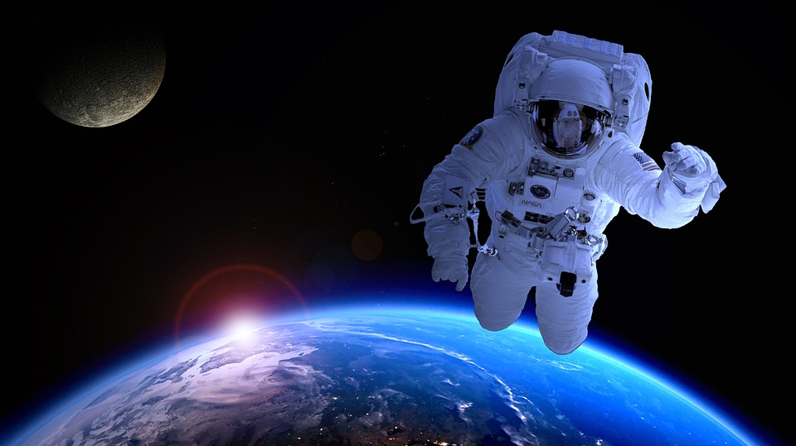

Lesson 2

15 Before learning about production of materials on space stations try to answer the following questions. How many of them can you answer?

1. How interested are you in space?
2. What advances in space research do you know?
3. What have you read or seen about production in space?
4. What physical phenomena govern the process onboard the spaceship?
5. What influence does gravity have on the final product
6. How can we use the acquired knowledge and data to improve industrial processes on Earth ?

16 Look at the adjective form of nouns.
A. Noun (существительное) + ful = Adjective (прилагательное)
e.g. use (польза) – useful (полезный), skill (умение, навык) – skillful (умелый, профессиональный)
Form adjectives from the following nouns.
success - ___________________________  wonder - ___________________________  beauty - ___________________________ | stress - ____________________________  help - _____________________________  care - _____________________________
B. Noun (существительное) + less = Adjective (прилагательное)
e.g. use (польза) – useless (бесполезный)
Form adjectives from the following nouns.
weight - __________________________  wire - ___________________________  mind -___________________________ | harm -___________________________  water-__________________________  end - ___________________________

C. Adjective (прилагательное) + ness= Abstract noun (абстрактное существительное)
e.g. weightless (невесомый) – weightlessness (невесомость)
Form nouns from the following adjectives.
useful - ___________________  tired - ____________________  busy - ____________________ | thick - ____________________  hard - ____________________  dark - _____________________

17 Read and translate the following international words from the text “Creating Materials in a Weightless Environment”.
product |ˈprɒdʌkt|, experiment |ɪkˈspɛrɪm(ə)nt|, defect |ˈdiːfɛkt|, processing |ˈprəʊsesɪŋ|, theorize |ˈθɪərʌɪz|, temperature |ˈtɛmp(ə)rətʃə|, ceramics |sɪˈræmɪks|, component |kəmˈpəʊnənt|, gallium |ˈɡalɪəm|, zinc |zɪŋk|, oxide |ˈɒksʌɪd|, zirconium |zəːˈkəʊnɪəm|, barium |ˈbɛːrɪəm|, lanthanum |ˈlanθənəm| , aluminum |əˈluːmɪnəm|, effect |ɪˈfɛkt|.

18 Read and learn pronunciation of the words from the text “Creating Materials in a Weightless Environment”.
alloy |ˈælɔɪ| , although |ɔːlˈðəʊ|, advent|ˈadv(ə)nt|, variety |vəˈrʌɪəti| , mold |məʊld|, thoroughly |ˈθʌrəli|, partially |ˈpɑːʃ(ə)li|, certain |ˈsəːt(ə)n|, vital |ˈvʌɪt(ə)l|, microsurgery |mʌɪkrə(ʊ)ˈsəːdʒ(ə)ri|, impurity |ɪmˈpjʊərɪti| , Earth |əːθ|, sample |ˈsɑːmp(ə)l|, researcher |rɪˈsɜːtʃə|, precisely |prɪˈsʌɪsli|.

Vocabulary

advent n | появление | mold n/v | шаблон, литейная форма/формовать
alloy n | сплав | movement n | движение
although adv | хотя; несмотря на то, что | precisely adv | именно, точно
application n | применение
certain adj | определенный | process n/v | процесс/обрабатывать
create v | создавать | property n | свойство, характеристика
data n | данные | research n/v | исследование/исследовать
dedicate to smth v | посвящать чему-либо (кому-либо) | raw materials | сырье
diminish v | уменьшать, убавлять,  сокращать | separate v | отделять, разделять
eliminate v | устранять, ликвидировать | sustain v | поддерживать, выдерживать
improve v | улучшать | thus adv | так, таким образом
impurity (мн.ч. –ies) n | примесь (примеси) | valuable adj | ценный
introduce v | вводить, представлять, знакомить, применять, привносить | vital adj | очень важный (жизненно важный)
melt n/v | расплав, плавка/таять, плавить | weight n | вес

19 Read the text paying attention to the words in bold. Make sure you know what they mean.

Creating Materials in a Weightless Environment
The weightless environment on space stations was of as much interest to materials scientists as to any others. Scientists are interested in a variety of physical properties of materials, such as melting points, molding properties, and the combining or separating of raw materials into useful products. Before the first space stations, materials scientists could perform simple experiments of very short duration aboard plummeting airplanes¹ and from tall drop towers. Through these studies, scientists discovered that gravity plays a role in introducing defects in crystals, in the combination of materials, and in other processing activities requiring the application of heat. Until the advent of space stations, however, they were not able to sustain a weightless environment long enough to thoroughly study these phenomena.
The advent of space stations allowed the study of new alloys, protein crystals for drug research, and silicon crystals for use in electronics and semiconductors. Materials scientists theorized that improvements in processing in weightlessness could lead to the development of valuable drugs, high-strength, temperature-resistant ceramics and alloys, and faster computer chips.
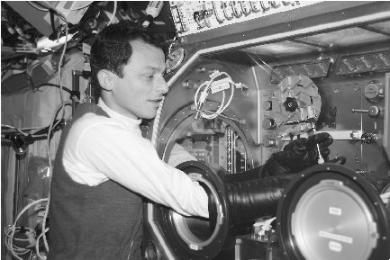
Using the ISS's Microgravity Science Glovebox, an astronaut studies the effects of weightlessness on various materials. In a weightless environment, scientists are able to remove impurities from most materials.

One of the Mir components, the Kristall module, was partially dedicated to experiments in materials processing. One objective was to use a sophisticated electrical furnace in a weightless environment for producing perfect crystals of gallium arsenide and zinc oxide³ to create absolutely pure computer chips capable of faster speeds and fewer errors. Although they failed to create absolutely pure chips, they were purer than those they could create within Earth's gravitational field.
More recently, fiber-optic cables are also being improved in weightlessness. Fiber-optic cables, vital for high-speed data transmission, microsurgery, certain lasers, optical power transmission, and fiber-optic gyroscopes4, are made of a complex blend of zirconium, barium, lanthanum, aluminum, and sodium5. When this blend is performed in a weightless environment, materials scientists are finding them to be more than one hundred times more efficient than fibers created on Earth.
In 2002 the ISS began the most complex studies of impurities in materials and ways to eliminate them in a microgravity environment. One of the most interesting causes of impurities, for example, is bubbles. On Earth, when metals are melted and blended, bubbles form. According to materials scientist Dr. Richard Grugel, "When bubbles are trapped in solid samples 6, they show up as internal cracks7 that diminish a material's strength and usefulness." In a weightless situation, however, although bubbles still form, they move very slightly thus reducing internal cracks. Secondarily, their slow movement allows researchers to study the effect of bubbles on alloys more easily and precisely.
According to Dr. Donald Gillies, NASA's leader for materials science, the studies of bubbles and other mysteries of materials production hold promise for new materials:
We can thank advances in materials science for everything from cell phones to airplanes to computers to the next space ship in the making8. To improve materials needed in our high-tech economy and help industry create the hot new products of the future, scientists are using low gravity to examine and understand the role processing plays in creating materials. (533 words, about 3400signs)

Notes to the text:
¹ plummeting airplanes – падающие самолеты
² drop towers - вышки для ударных испытаний (сбрасывания высоты)
³ gallium arsenide and zinc oxide – арсенид галлия и оксид цинка
4optical power transmission, fiber-optic gyroscopes – передача оптической энергии, волоконно-
оптические гироскопы
5zirconium, barium, lanthanum, aluminum, and sodium – цирконий, барий, лантан, алюминий и
натрий
6 when bubbles are trapped in solid samples – когда пузырьки застревают в твердом образце
7 they show up as internal cracks – они выглядят как внутренние трещины
8 in the making – в процессе становления, в процессе развития

20 Match the synonyms to the words. Give Russian equivalents to all these words.

advent | exactly
able | to permit
application | to fulfill
to eliminate | mix
precisely | usage
to improve | to remove
to allow | produce
to create | capable
blend | to make
product | arrival
to perform | to make better

21 After reading mark TRUE or FALSE statements. Correct the false ones.
1. Scientists discovered that weightlessness plays an important role in introducing defects in crystals. T/F
2. It became possible to sustain weightlessness on Earth long time ago. T/F
3. The advantages of the zero-gravity state may result in the development of different materials with improved qualities. T/F
4. The Kristall module was partially aimed at performing experiments in materials processing. T/F
5. One objective was to use an electrical cooker in a weightless environment for producing perfect crystals of gallium arsenide and zinc oxide. T/F
6. The computer chips were purer than those they could create within Earth's gravitational field. T/F
7. Materials scientists are finding fiber-optic cables to be more than one million times more efficient than fibers created on Earth. T/F
8. In a weightless situation bubbles move very slightly thus reducing internal cracks. T/F
22 Put the correct words from the table below in the above article.
The weightless environment on space stations (1)_____ of much interest to materials scientists. Scientists are (2) _____________ in various properties of materials, such as melting points, molding characteristics, and the combining or separating of raw materials into products. (3)____________ the first space stations, materials scientists performed short experiments aboard plummeting airplanes and from tall drop towers. They discovered that gravity plays a role in introducing (4)___________ in crystals, in the combination of materials, and in other activities. Until the (5)_____________ of space stations, however, scientists were not able to sustain weightlessness long enough to study these phenomena.
The advent of space stations allowed the study of new alloys, protein crystals for drug research, and silicon crystals (6) _____use in electronics and semiconductors. Materials scientists theorized that improvements in processing in weightlessness could lead to the (7)_______________ of valuable drugs, high-strength, temperature-resistant ceramics and alloys, and faster computer chips.
The Kristall module, was (8)_____________ dedicated to experiments in materials processing. One objective was to use a sophisticated electrical furnace in a weightless environment for producing perfect crystals of gallium arsenide and zinc oxide¹ to create absolutely pure computer chips capable of (9)___________speeds and fewer errors.
(10)________ recently, fiber-optic cables are also being improved in weightlessness. Fiber-optic cables, vital for high-speed data transmission, microsurgery, certain lasers, optical power transmission, and fiber-optic gyroscopes, are made of a complex blend of zirconium, barium, lanthanum, aluminum, and sodium. When this blend is performed in a weightless environment, materials (11) ___________ are finding them to be more than one hundred times more efficient than fibers created on Earth.

1. | (a) | was | (b) | as | (c) | will | (d) | has
2. | (a) | interesting | (b) | interest | (c) | interested | (d) | interests
3. | (a) | before | (b) | after | (c) | as soon as | (d) | when
4. | (a) | errors | (b) | defects | (c) | mistakes | (d) | bugs
5. | (a) | advent | (b) | arrival | (c) | appearance | (d) | coming
6. | (a) | for | (b) | to | (c) | by | (d) | at
7. | (a) | develop | (b) | development | (c) | developing | (d) | developed
8. | (a) | totally | (b) | wholly | (c) | completely | (d) | partially
9. | (a) | faster | (b) | higher | (c) | lower | (d) | slower
10. | (a) | Many | (b) | Much | (c) | More | (d) | Multi
11. | (a) | lab assistants | (b) | astronauts | (c) | workers | (d) | scientists

23 Work in pairs: take turns to ask and answer the questions to the text “Creating Materials in a Weightless Environment“

1. What natural phenomenon with regard to space were scientists interested in?
2. What kind of experiments did materials scientists perform before the first space stations?
3. What did they discover through these studies?
4. When did it become possible to sustain weightlessness long enough?
5. What did the advent of space stations allow us to study?
6. In which spheres of our life can improved materials be applied?
24 Test each other: Look at the words and word combinations below. With your partner, try to recall the context they were used in.

- space stations  - semiconductors  - an electrical furnace  - pure chips | - fiber-optic cables  - a complex blend  - impurities  - bubbles

25 Complete the Table (column “Application on Earth”) using the information from the text “Creating Materials in a Weightless Environment“

Conditions on board the spaceship/equipment on board the space ship | Objects of study  (materials/products) | Made of/composed of | Application on Earth
weightlessness (gravity) | new alloys  protein crystals | -
 | silicon crystals | -
electrical furnace in a weightless environment | perfect crystals | gallium arsenide and zinc oxide
weightlessness | fiber-optic cable | a complex blend of zirconium, barium, lanthanum, aluminum, and sodium
microgravity environment | impurities in materials  (bubbles) | -

26. Summarize the information on materials research in space using the following plan.

1. The effects of weightlessness on various materials
2. The role of space stations in the production of new materials and products
3. The results of the experiments performed on board the space station
27. Translate into English using modal verbs can, must, need, may or their equivalents if possible.
1. Изменение физических свойств материалов можно изучать на борту космической станции.
2. В результате экспериментов в условиях невесомости ученые должны найти способы устранения примесей в материалах.
3. Космонавтам не нужно доставлять громоздкие (bulky) конструкции с Земли, так как их следует изготавливать на борту станции.
4. Компания “ Made in Space” смогла создать технологию 3Д печати, которая может быть использована для замены поврежденных деталей непосредственно на МКС.
5. Иногда космонавты вынуждены изготовлять деталь вне МКС в вакууме космоса.
6. Новая технология позволила производить инструменты на борту, что необходимо для длительных (long term) космических полетов.
7. Несмотря на то, что А.Энштейн смог предсказать (predict) гравитационные волны столетие назад, их существование было доказано совсем недавно.

Lesson 3

Grammar
Part 2. Modal verbs expressing possibility and certainty.

28 (file 3) Listen to the explanation of how to use modals of possibility and certainty. Complete the sentences. (1:37 min)

Modal verbs (called modals for short) are _________(1) verbs that express a speaker’s attitude and the strength of that attitude. There are about __________(2) modals in English.
A person who is 100% sure uses the verb be as in "I ______(3) sick." If they are mostly sure, say 95%, they will use the modal _______(4), as in "I ______(5)be sick." When speakers are about 50% sure, they will use the modals may, might, or could; as in "I __________(6) be sick. I _____________(7) be sick. I _______________(8)be sick."

What modal verbs will you use to express your certainty of 95%, 50%?

29 Fill in each gap using one of the modals of possibility or certainty.

e. g.I'm sure he is here - I can see his car in front of the building.
He must be here. I can see his car in front of the building.
- They're coming this week but I don't know which day.
They _______ be coming tomorrow.
- I'm not sure I'm going to pass the exam. I don't feel very confident. I _______ pass the exam. I don't feel very confident.
- I've bought a lottery ticket. There's a chance I'll become a millionaire!
I ______ become a millionaire!
- I'm sure she doesn't speak French very well - she's lived in Paris only for a few weeks.
She _________ speak French very well. She's lived in Paris only for a few weeks.
- My key's not in my pocket or on my desk, so I'm sure it's in the drawer.
My key's not in my pocket or on my desk, so it ________ be in the drawer.
- Someone told me that Mark was in Mexico but I saw him yesterday, so I'm sure he's not abroad. Mark ________ be abroad.
- You got the job! That's great! I'm sure you're delighted.
You got the job! That's great. You_______ be delighted.
- They told me to prepare the project by tomorrow, but it’s almost impossible to have it done so fast.
I _______ finish it by tomorrow if I stay at work all night, but I'm not sure.
- I asked them to send the goods as soon as possible; we _______receive them by the end of the week if the post is fast.

30 Work in pairs. Paraphrase the sentences using the modal verb may/might to express probability

Student 1  I don`t know when the experiment is going to start. Possibly it is going to start in an hour. | Student 2  I don`t know when the experiment is going to start. It may start in an hour.

1. The Universe is probably much bigger than we can see. 2. I suppose, there are other Universes, parallel Universes. 3. I don`t know where astronauts train to prepare for microgravity. Possibly they train underwater. 4. Wearing a space suit is probably a difficult task. 5. Perhaps one day production in space will become routine. 6. I don`t know how to apply for this course. I`ll probably write a letter of application. 7. Alan wasn't at the last meeting. I suppose he doesn`t know the new members of the crew. 8. Helen sustained a stress. I'm afraid she won`t pass her exam.

31 Rewrite the sentences in italics with must.
e.g. Her light's on. She's certainly in. She must be in.
1. John's coming to see me. I`m sure he wants something. He …
2. Listen to her accent. I feel sure she`s French. She…
3. Look at all those books. He certainly reads a lot. He …
4. So you're studying politics. I`m sure that`s interesting. It…
5. Are those his shoes? He certainly has very big feet. His feet…
6. Do you live in Barton? You certainly know Paul Baker.You…

32. Watch the video “Benefits for Humanity. Hope Crystalizes” (4:48 min) and answer the questions. Use the prompts.
https://www.youtube.com/watch?v=hCWqNy6tVOM

Useful notes

Duchenne Muscular Dystrophy (DMD) - мышечная дистрофия Дюшенна
incurable genetic disorder – неизлечимая генетическая болезнь

adolescence |adəˈlɛs(ə)ns| – юность, молодость
1 What is this video about?
Earth/application/ISS research
2 What are the growing conditions of high quality crystals?
they/grow/ microgravity
3 What is the investigation of protein crystals in space helping treat?
treat/ DMD/affect/muscles/young boys
4 Why couldn’t scientists grow a crystal on Earth?
gravity/impact (влиять)/quality/crystal
5 How many experiments have been conducted since 2003?
there/conduct/more/sixteen/
6 What is the result of the experiments?
are able/to slow/by half/
7 What are scientists going to do in the future?
determine/ thousands of proteins/structures/
8 Who are they doing this research for?
not only/ourselves/generation/to come

Phrases due to, thanks to, because of and no longer

33. Translate into Russian the following sentences with the phrase prepositions due to, thanks to, because of
1. Ships could communicate over long distances thanks to the invention of radio. 2. Because of the earth's rotation there are days and nights on the earth. 4. Perhaps the blue color of water and ice is due to the light and air they contain. 5. Thanks to the development of radio telescopes radio astronomy has made great achievements. 6. Our century can be called “Space Age” because of the development of a new branch of science and technology - cosmonautics. 7. Many well-known processes go on differently due to the absence of weight.

34. Complete the sentences using due to, thanks to, because of
A.
1. Even in quiet weather conversation is difficult | because of  due to  thanks to | the weightlessness.
2. The bubbles move very slowly | because of  due to  thanks to | the wind.
3. There are a lot of power cuts in this area | because of  due to  thanks to | his boss.
4. Everyone knows when I'm lying | because of  due to  thanks to | the advent of space stations.
5. Frank wants to find another job but doesn't have a lot of confidence | because of  due to  thanks to | the miracle of television.
6. You will have to wait | because of  due to  thanks to | the weather.
7. It became possible to sustain a weightless environment long enough to carry out experiments | because of  due to  thanks to | the expression on my face.
8. We can watch events happening on the other side of the world | because of  due to  thanks to | the high number of calls today.

Remember!
Because (conjunction) and because of (preposition) are different.
We stayed in because it was raining - We stayed in because of the rain.

B. Change the sentences following the rule in Remember section.
1. He was able to go to university because his uncle helped him.
2. Because I was unhappy, I didn't want to see anybody.
3. Ann arrived late because there was a problem at the airport.
4. We couldn`t play match because the weather was bad.
5. I couldn't understand them because they had an accent.
6. We had to drink a lot because it was hot.
7. I couldn't go away last weekend because I worked.
8. I couldn't understand her because I was tired.

35. Change the following negative sentences using negation no longer in accordance with the model
e.g. It isn`t possible to put off the solution of ecological problems any longer. - It is no longer possible to put off the solution of ecological problems.

1. People don`t think of radio and television as something fantastic any longer.
2. In space the Archimedes principal is not valid any more.
3. Now, with these food delivered by the space shuttle a few times a year, you don`t have to take special pills any longer.
4. When we are not able to change a situation any longer, we are challenged to change ourselves.
5. We have a small two-door wardrobe we do not need any more .
6. He was told he didn`t have a job any more.
7. Due to understanding of the protein’s shape this genetic disorder isn`t hopeless any longer.

Discussion
Space research is a waste of money. vs. Space research is money well spent.

36 Work in pairs or in small groups.

Students A strongly believe discoveries in space are very important;
Students B strongly believe they are not. Change partners again and talk about your conversations. Use the following phrases:

Lesson 4

37 Look at the pictures and match them to the words in the box

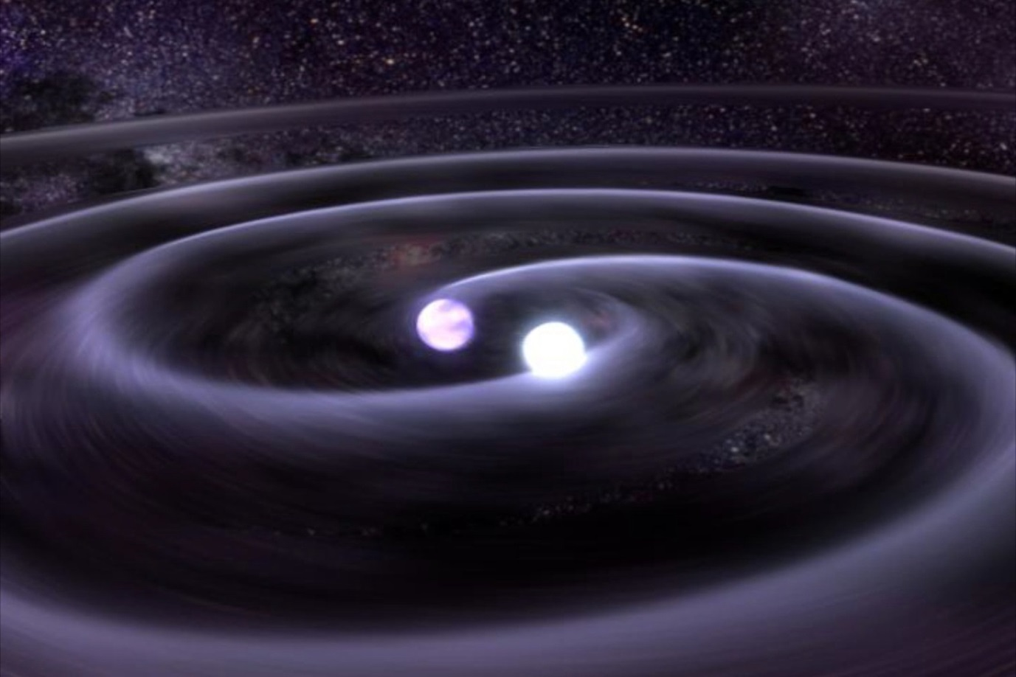 | 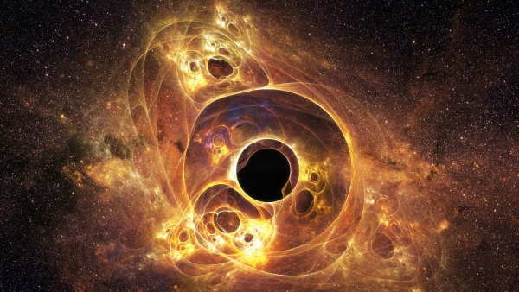 | 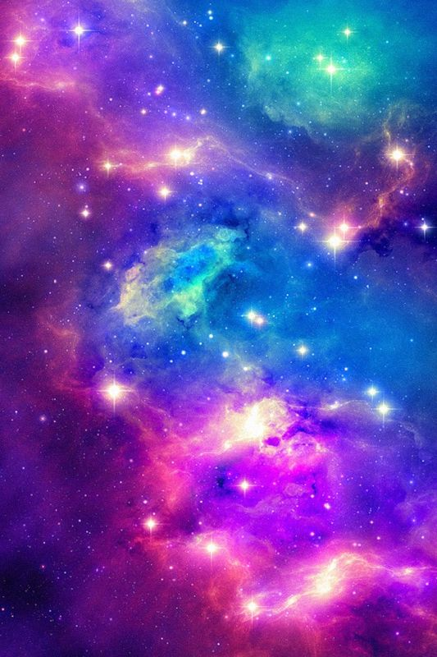 | 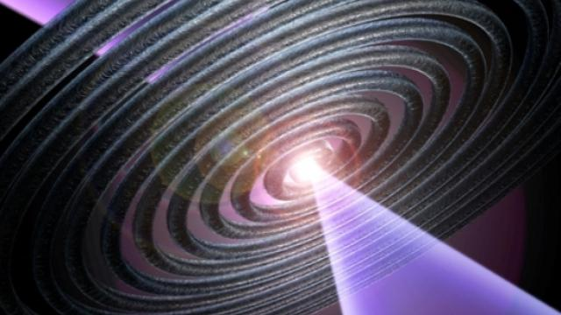
1_______________ | 2_____________________ | 3___________________ | 4__________________

galaxy gravitational waves ripple black hole

38. Listen to a story “Gravitational Waves Detected, Einstein Is Right”

Before you start listening read the vocabulary and look through the questions
ripple – n. рябь, расходящийся волнами, пульсация
predict – v. предсказывать; прогнозировать
detect – v. находить; обнаруживать; открывать;
violent – adj. неистовый; яростный; ожесточённый; отчаянный; сильный
crash - v. сталкиваться; разбиваться на куски; раздробляться
black hole - n. черная дыра
ripple in the fabric of space-time – phrase: волна, проходящая рябью по космическому пространству
spin (v.) - вращать(ся) вокруг продольной оси;
galaxy – n. Галактика

39 Answer the following questions.

1. When did Albert Einstein first talk about the waves?
2. What things must hit each other in space for the waves to form?
3. What are the gravitational waves like?
4. Can you see the gravitational waves with your eyes?
5. What did the scientists use to find them?

40 Listen to a part of the story again and complete the sentences below.
It took __o___h____(1) years, but finally, scientists proved Albert Einstein’s theory that gravitational waves e__________(2). The waves were predicted as part of Einstein’s General Theory of Relativity nearly 100 years a_______(3). It was the theory of the physics behind the workings of our world and the u_______________(4).
The idea was that the waves are like ripples in s_____(5), caused by some of the violent and energetic processes in the Universe. For example, two b______ h_________ (6) crashing into each other.
Now a group of scientists, i_________(7) ones from from CalTech, MIT and the LIGO Scientific Collaboration finally found the gravitational waves.
David Reitze is the executive director of the LIGO observatory at CalTech.
“We have d________(8) gravitational waves. We did it! “
41 With your partner, take turns to ask each other questions.
STUDENT A’s QUESTIONS (Do not show these to student B)
1. What springs to mind when you hear the word 'space'?
2. How interested are you in space?
3. What do you think about what you read about gravitational waves?
4. What do you know about Einstein?
5. What do you know about Einstein's General Theory of Relativity?
6. What do you want to know about space?
7. Do you think there is life on other planets?

STUDENT B’s QUESTIONS (Do not show these to student A)
10. | What is the most important discovery ever?
11. | What is the most important invention ever?
12. | What questions are there about our universe?
13. | Will everything in science fiction movies come true?
14. | Would you be a good scientist?
15. | Do you think we will find something in space we won't like?
16. | Would you like to explore space?
42 Read the title of the article and answer the questions:
A. 1. What is the topic of the article?
2. What kind of person would be interested in this article?

Roscosmos starts recruitment of cosmonauts for future lunar missions
ZVEZDNY GORODOK /Moscow region/, April 5. /TASS/
B. Now read the first paragraph of this article and decide whether you were right or wrong
Russia’s Cosmonauts Training Center plans to double and even triple the amount of candidates during the upcoming supplementary recruitment campaign, compared to the previous one, the center’s head Yuri Lonchakov told reporters on Wednesday. "There are two aspects to the recruitment process, as it requires a technical education and flight training. In addition, the applicants will take tests in physics, mathematics, the Russian and English languages and the history of culture," the head of the Cosmonauts Training Center added.
43. Andrew Nikonov (a BMSTU graduate) has decided to write a letter of application to the Cosmonauts Training Center. He is required to write letters both in Russian and in English to demonstrate a good command of English.
In his letter below, the paragraphs are out of order. Read the letter and write the correct order of paragraphs.
1.___________ | 2.__________ | 3.___________ | 4.___________ | 5._________

Dear Mr. Lonchakov,
A. The opportunity presented is very interesting, and I believe that my strong technical experience and education will make me a very competitive candidate for this position.
B. I am writing to apply for the cosmonaut position advertised on your website. As requested, I am enclosing a completed job application, my certification, my resume, and three references. The site says you need a person with analytical skills and interest in space engineering and high-speed travel. The position seems to fit very well with my education, experience, and career interests.
C. Please see my resume for additional information on my experience.
I can be reached anytime via email at ___________@_____.ru or my cell phone, 909-555-5555.
Thank you for your time and consideration.
D. With a Master’s degree and three years’ work experience in the aeronautical industry I have a full understanding of the basics of manned space flights and have a good knowledge of Russian, English, and the history of space travel in Russia.
E. I look forward to speaking with you about this employment opportunity.
Yours sincerely,
44 Now you want to apply for the Aeronautical Engineering course. The course gives you the chance to advance your future career to management levels, testing and design positions within the aeronautical industry. Write a letter of application using the underlined phrases in ex. 43
Useful notes:
I am a first year student studying…..
I became interested in…
I was responsible for …
I therefore have a strong understanding of how …
I appreciated working with…

Speaking

45. Debate these fun arguments for just two minutes each. Student A agrees with the first argument, Student B, with the second. Use the following expressions:

In my opinion,….. From my point of view….. I believe…… In the future, I think….
I don`t agree with you… I don`t really think… I`m afraid I can`t agree with that idea…
- Living in space would be crazy. vs. Living in space would be awesome (потрясающе).
- Weightlessness would be wonderful. vs. Weightlessness would be boring.
- Being on Earth is more beautiful. vs. Looking at the earth is more beautiful.
- An astronaut is the best job in the world. vs. There are better jobs.
- Living in space is bad for your health. vs. Living on Earth is bad for your health.
- A holiday in space would be exciting. vs. A holiday in space would be stressful.
- We will have to live in space one day. vs. We will always be able to live on Earth.
- China will be the leader in space exploration. vs. Russia will always be first.
- Space research is a waste of money. vs. Space research is money well spent.

46 Make presentations on the topic “Advances in Space Research”. (Use the texts “Creating Materials in a Weightless Environment” and “Gravitational Waves Detected, Einstein Is Right”, and your own findings). The following websites might be helpful:
http://www.nasa.gov National Aeronautics and Space Administration
http://www.esa.int - European Space Agency
http://www.federalspace.ru/ Russian Space Agency
http://space.skyrocket.de/
http://www.planet4589.org/space/
http://www.spacefacts.de
http://www.space.com
http://spaceflight.nasa.gov
http://www.spacelist.org
http://www.russianspaceweb.com/

Consolidation

Module 6 Test V.0

I. Translate into Russian 2 points

1. Complex materials fiber-optic cables are made of can be improved in the weightless
environment.
2. New technologies should be used in space research and cosmonauts will be able to
research gravity.
3. Microgravity allows researchers to remove impurities from the most materials.
4 Some people believe we needn’t waste money on too expensive space research.

II. Translate into English paying attention to the underlined words (Active vocabulary) and/or Grammar of the Module (Modal verbs) 2 points

1. Улучшенные благодаря невесомости свойства материалов могут привести к созданию ценных медицинских препаратов.
2. Производство в космосе должно помочь устранить мелкие недостатки, из-за которых ухудшается сигнал оптоволоконного кабеля.

III. Complete the sentences using a modal verb or its equivalent in the correct form.
2 points
1. In the near future China ___________ become the leader in space exploration. (возможно)
2. In accordance with the space programme cosmonauts ________ study the properties of materials in space. (должны в силу запланированности)
3. The astronaut profession _____________called one of the riskiest in the world. (может быть названа)
4. Engineers _________ carry out complex tasks to apply new technologies. (могли)

IV. Unjumble the words and write two or three more sentences on the given topic. 4 (2+2) points
Scientists are trying to get humans to Mars. Researchers are currently trying to find out what kind of plants (1) in could on the red grow soil Mars. They hope that astronauts (2) to will growing able be start their own food on the Red Planet. The journey to Mars (3) take could to two-and-a-half up years. The astronauts (4) with will of take a need to lot food them just to last for the journey.

Could you be an astronaut? URL: http://www.bbc.co.uk/learningenglish/english/features/6-minute-english/ep-160526
http://learningenglish.voanews.com/media/video/everyday-grammar-tv/3137097.html?z=0&zp=1 (file 2)
April 27, 2016 by Sabrina Gaertner, The Open University, The Conversation https://phys.org/news/2016-04-microgravity.html
По материалам http://www.scienceclarified.com/scitech/Space-Stations/Research-and-Experiments.html#ixzz40M3Pi5Z7
http://learningenglish.voanews.com/content/everyday-grammar-may-might-must-modals-certainty/2887387.html (file 3)
http://learningenglish.voanews.com/content/eistein-is-proven-right/3188629.html (file 4.1 or 4.2)

